- completed
-partially
- Dashboard:
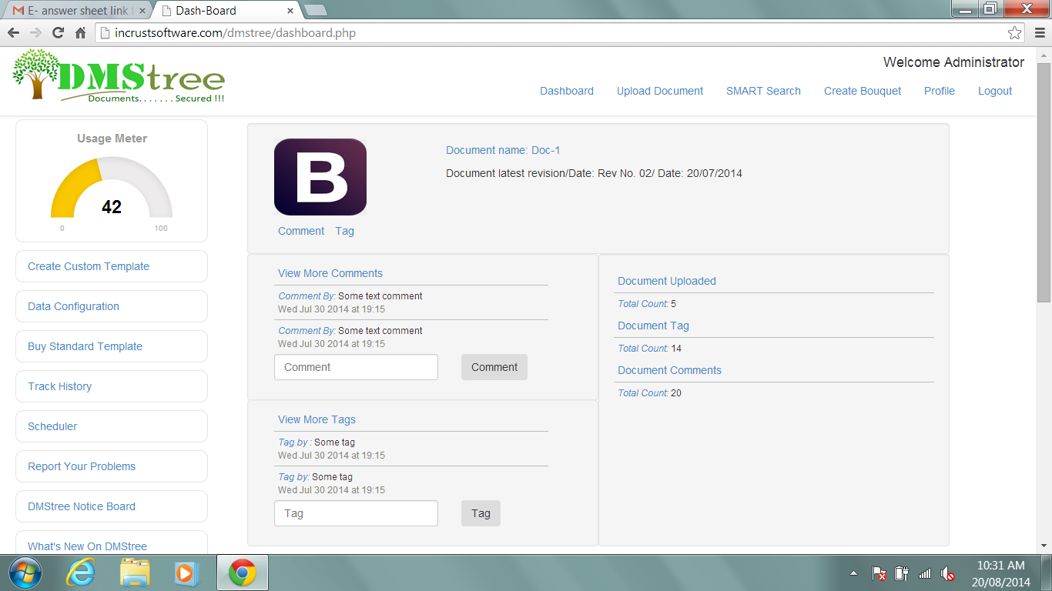
3
4
1
1
2.2
- Dashboard showing Comment by/Tag by and then the comment that has been posted. Here what it means by Comment by/Tag by? Whether we are going to display name of users like ‘Commented by Pushkaraj:’ ?
Ans. ) Yes, it will display name of commented or tagged person’s name.

- Delete Scheduler option

- What is mean by ‘Document uploaded count’?
Ans. ) ??? It will show the count of document uploaded with it.

- What is expected to happen if I press this comment or tag links? If it is only to open comments and tags, It’s already appearing in next column View more comments/tags. Then is this link is required?
Ans. ) The comments and tag link is used to focus the comment input box and tag input box on click.
- Can we squeeze this document view further so that at least two latest documents will appear without going down?

- Upload document:
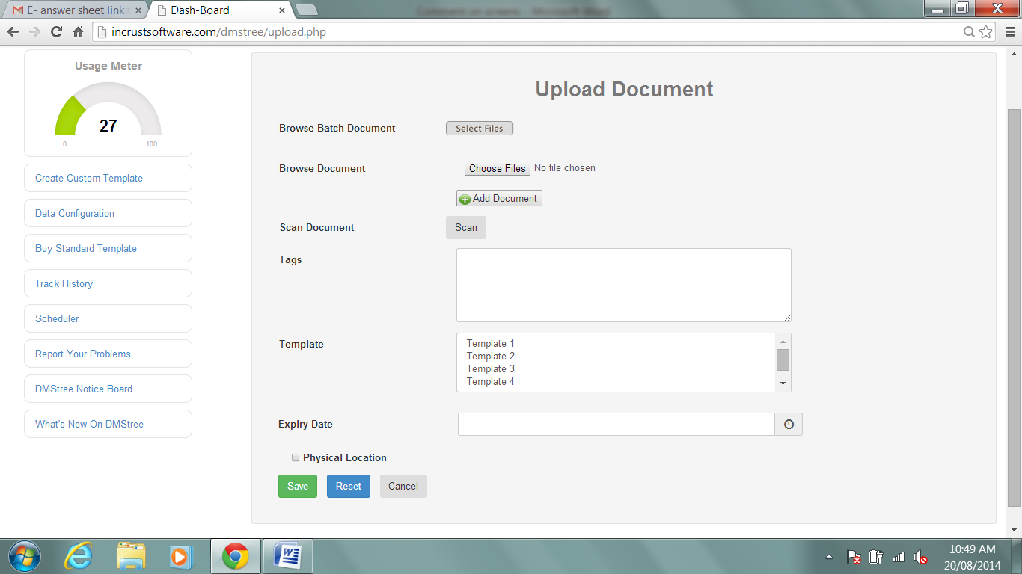
1
2
4
3
- Process of upload document is possible by only one method, either through batch upload or individual upload. Hence we have to provide option to select process of upload. And accordingly batch or individual upload facility will visible/enable.

- Remove Scan option as we are not providing direct scanning facility

- Selection of template is not showing any template. I hope it is because of unavailability of database at. back end. Please confirm the same.
Ans. )Data was missing.

- Expiry date field is not showing any calendar so to select appropriate date. Also add provision so that user will not be able to select back date as expiry date. i.e. if I’m adding new document on 20th August 2014, I cannot say this document will expire on 19th August 2014 or any past date.
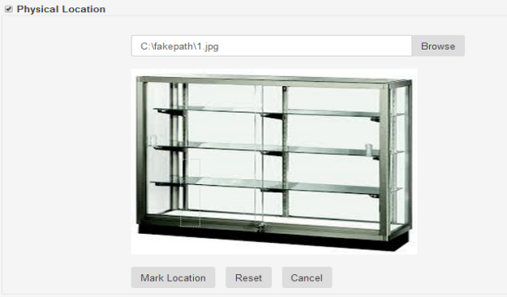

- It is taking default window to enter text irrespective of size of any cupboard box. In above figure I want to add some text at lower most section of rack. However default setting allowing me to write text on second rack from bottom. How to tackle this? We should have facility to select particular area and accordingly text matter should appear.
- SMART Search:
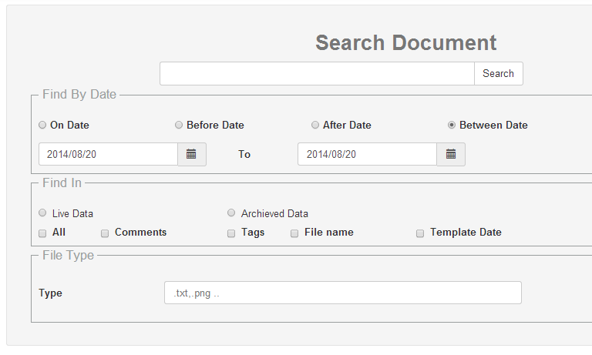
2
5
4
3
- Can we compress filter option part? At this moment if I search something, I cannot see document without scrolling down. ??????

- Can we add two more options in date filter? ‘In this week’ and ‘In this month’?
? week means - 7 days form present day

- In case of between dates option, to date must be next to from date. We may add such logic or in case of wrong selection user should get message box.

- After selecting ‘All option’ in find in frame, make all other options disable.

- Its ‘Template Data’
Ans.) Yes.

- Profile:
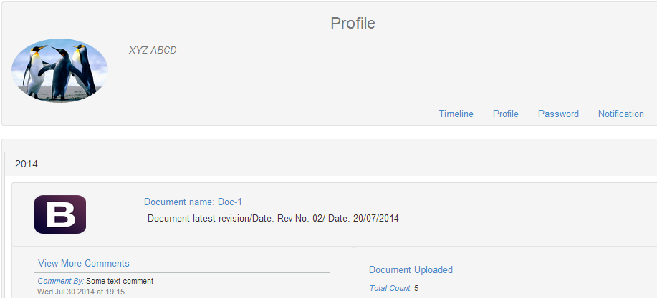
1, 2
1

- Can we add Timeline and Notification buttons in main menu? On dashboard? As per my understanding here timeline is user’s timeline and not for specific document. Similarly main purpose of notifications is to alert users about latest updates. Hence it’s better if we can arrange them on dashboard. (Notification is only applicable in corporate plan.)
Ans. )Notification removed
- What will be the limitation for timeline of user? Till which date he/she can see data? Is there any logic/check available for the same?

- Create Custom Template
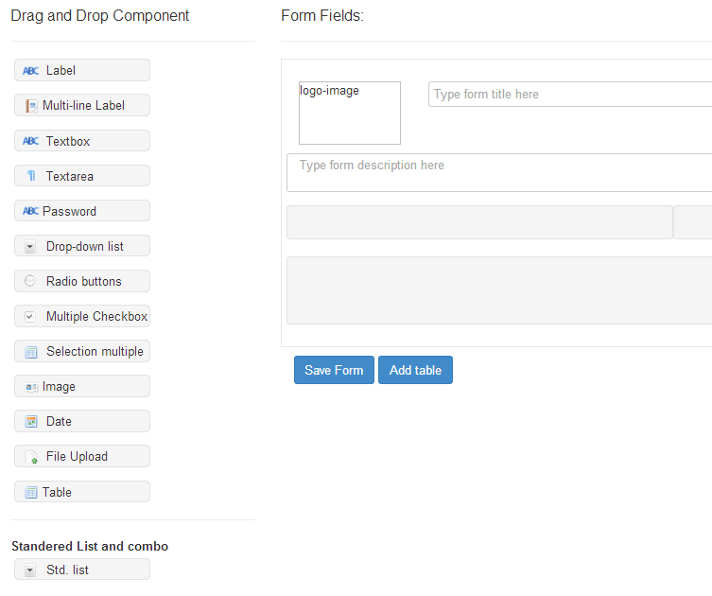
7
6
5
4
3
2
1

- Multi line label is not working properly. When I press enter, system should allow me to enter data on next line in same label.

- What is use of Password field here in template?

- Radio buttons appearing in form are very small and difficult to select due to small size.

- Image is appearing in predefined size; however it should have size options. Even we can add same logic as font. Image can appear in given box with size variations as Small, Medium, and Large. All sizes will have pre-defined sizes.

- Date function is not showing calendar on first click. However on second click it appears. Correct the same.

- File upload field is not required in template creation. You can remove the same from this list.

- If I add table in any template, system should not allow me to save that particular template till I select number of rows and columns. Also add facility to provide labels to rows. In such case table will not be dynamic. And ‘Add row’ button will not appear.

- Data configuration:
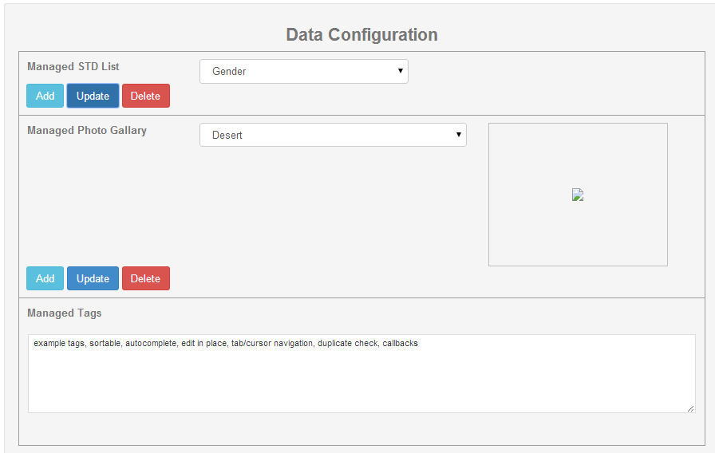
1
1

- Add constraint to Std. List names. All names have to be unique.

- How this photo gallery function is going to work?

- Make labels as Manage STD List, Manage Photo Gallery, Manage Tags

- Can we add Find and replace tag functionality here?

- Report a problem: We have to build screen for reporting problem. Sample screen is attached in excel master.

- DMStree Notice board will be similar to Report a problem screen. Where our Super admin can add HTML pages or can send plain text.

- Create Bouquet screen is pending

- ‘View Document’ screen is pending which will be appear if I select any document after searching it through search engine. ‘View Document’ screen will contain Check-In, Check-out buttons also user can view document in preview section if it is in appropriate format like .pdf, .txt, .xls, etc. (Refer Master document/Doc upload/last screen DT-001-007)

